+This symbol means that the pastor makes the sign of the cross. You may also choose to mark yourself with the sign of the cross.

This service starts with the Confession and Forgiveness. This is a time to be honest with ourselves and God and includes a confession of sins. Sin is anything (words, or actions) that separates us from honest and healthy relationship with God or with each other.

This is the time in our worship when all gathered are assured of God’s love and forgiveness. Relationships are restored. God is good and full of love. God’s grace and forgiveness can be trusted.

The Table Summer Worship 2020

This worship service includes places where the pastor or leader says something and the people respond together. You will be invited to sing. Worship is more than a show that you only observe, but is done together with all people participating. It may feel weird for you to say things together with everyone else. We get this and invite you to participate at your level of comfort.

WELCOME

CONFESSION AND FORGIVENESS
Pastor: Blessed be the Holy Trinity + the Creator, the Redeemer, and the Holy Spirit, whose love lasts forever, whose faithfulness lasts from generation to generation.
People: Amen.

A moment of silence for reflection.

Pastor: Reconciling God,

People: we confess that we do not trust your abundance, and we deny your presence in our lives. We place our hope in ourselves and rely on our own efforts. We fail to believe that you provide enough for all. We abuse your good creation for our own benefit. We fear difference and do not welcome others as you have welcomed us. We break our relationships with you and with other people in our thoughts, in our words, and in our actions. In your generous love, forgive us and make us new. In your Spirit, lead us; so that we might live and serve you in this new life. Amen.

Pastor: Beloved of God, by the radical abundance of mercy we have peace with God through + Jesus, through whom we have received the gift of unrestricted love. Our sins are forgiven. Let us live now in hope. For hope does not disappoint, because God’s love has been poured into our hearts through the Holy Spirit.

People: Amen.

GREETING
Pastor: The grace of Jesus, the love of God, and the communion of the Holy Spirit be with you all.

People: And also with you.

The Kyrie eleison (pronounced kheer – ee- eh eh-lay-ee-son) is an ancient Christian prayer in Greek. It means, “Lord have mercy.” This song is a request for God’s mercy, but is also a recognition and song of praise for God’s ongoing mercy.

The Gloria is a song of celebration and praise. It’s the song that the shepherds and angels sang on the night that Jesus was born. This is also an ancient song used in Christian worship.

Texas Kyrie by Jonathan Rundman

Leader: We pray for peace from above. We pray for our salvation. (To refrain)

Leader: We pray for peace in this world, we pray for wellness in your church, we pray for the unity of all. (To refrain)

Leader: We pray for this holy place. We pray for all who gather here. (To refrain)

Leader: Oh Lord help us, save us, Oh Lord comfort and defend us.

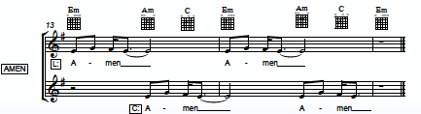

SONG OF PRAISE
Glory in the Highest
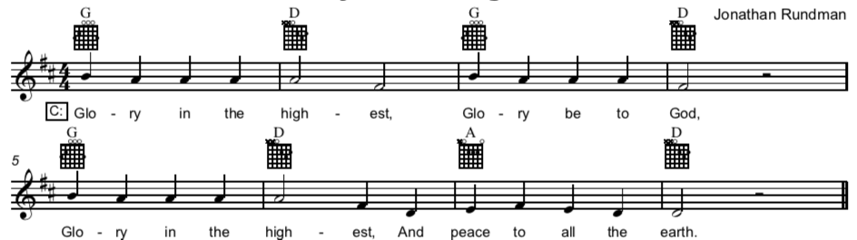

- Leader: Shaper of the Universe (repeat) Thanks and praise we sing (repeat)
Loving father, caring mother (repeat) Hold us in your wings (repeat) CHORUS

- Leader: Jesus Christ the Lamb of God (repeat) you wash our sins away (repeat)
At your table all are welcome (repeat) hear us as we pray (repeat) CHORUS

- Leader: Holy Spirit, source of life (repeat) burning wild and free (repeat)
You are God the three -in- one (repeat) such a mystery (repeat) CHORUS

The Passing of Peace is another ancient tradition where peace is made between people before participating in Communion. It’s a sign that people can be united (not uniform) when coming before God.

The Great Thanksgiving is a pattern and cluster of ancient Christian prayers that surround Communion. These prayers can be traced back as far as 215 CE.

The Preface is always a prayer which lists the many ways in which God is praised and thanked.

PRAYER OF THE DAY
People: You are great, O God, and greatly to be praised. You have made us for yourself, and our hearts are restless until they rest in you. Grant that we may believe in you, call upon you, know you, and serve you, through your Son, Jesus Christ, our Savior and Lord. Amen.

PASSING OF PEACE
Pastor: The Lord be with you.
People: And also with you.

The Great Thanksgiving

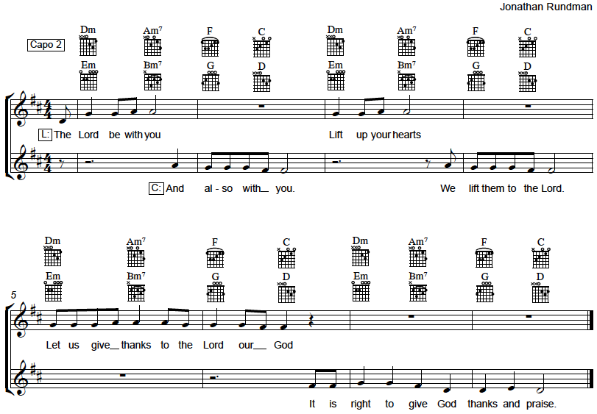

PREFACE
Pastor: It is indeed right and salutary that we should at all times and in all places offer thanks and praise to you O God, Wise Creator, through Jesus Christ our Lord, who on this day overcame death and the grave and by his glorious resurrection opened to us the way of everlasting life. And so with the church on earth and the hosts of heaven we praise your name and join your unending hymn.

The Sanctus (holy,holy, holy) is meant to be a joyful song of praise to God. This song anticipates and thanks God for God’s act of forgiveness and gift of deliverance from the power of sin and death.

SANCTUS
Holy, Holy, Holy
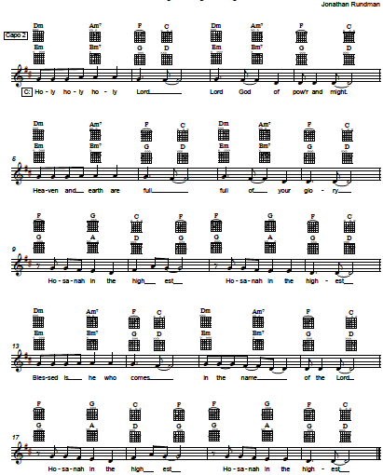

The Words of Institution are the words that Jesus spoke when he instituted or gave us the gift of Communion.

The Lord’s Prayer is the prayer that Jesus taught his followers to pray.

About Communion: Jesus is really present in this meal. No, we’re not cannibals…that would be gross. Clearly this is bread and wine or juice but this is a sacred meal. Jesus meets people here. The gifts promised in the sacrament of communion are: the forgiveness of sin, life, and rescue into eternal relationship with God. Participants are claimed as God’s people and take a piece of Jesus with them after this meal.

The words, “Lamb of God you take away the sin of the world” are another ancient part of Christian worship which comes from the Bible. It’s a reminder of the sacrifice of love and saving work of Jesus in his life, his death, and his resurrection.

THE WORDS OF INSTITUTION
(Please have your bread and wine or grape juice in front of you during the Words of Institution. When you hear the words, “The body of Christ broken in love for you,” share the bread with those around you, If you are alone, eat the bread as these words are spoken. When you hear, “The blood of Christ shed for you,” share the wine or grape juice with those around you repeating these words. If you are alone, drink your wine or juice as these words are spoken. For children, make the sign of the cross on their foreheads when you give them the bread. You may bless them by saying, “This is Jesus’ body. He loves you and you are a special child of God.”)

THE LORD’S PRAYER
People: Our Father, who art in heaven, hallowed be thy name, thy kingdom come, thy will be done, on earth as it is in heaven. Give us this day our daily bread; and forgive us our trespasses, as we forgive those who trespass against us; and lead us not into temptation, but deliver us from evil. For thine is the kingdom, and the power, and the glory, forever and ever. Amen.

COMMUNION
Pastor: Friends of Jesus, come to the table. The gifts of God are free. All are welcome at this meal.
Lamb of God

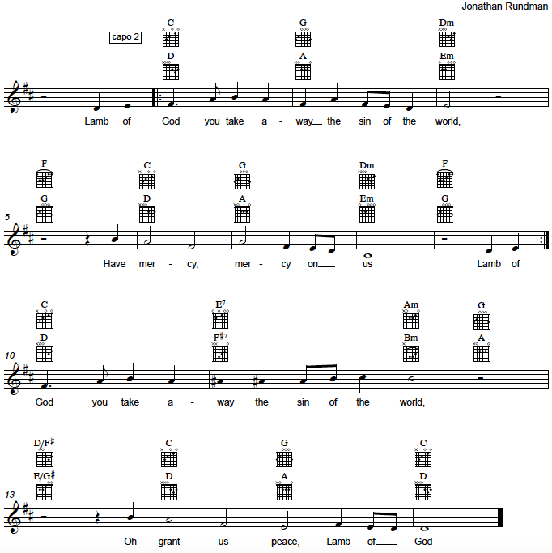

The Gospels are the books of the Bible which tell the story of Jesus and contain his words. We sing a Gospel Acclamation to announce the Gospel and celebrate.

dgBLESSING
Pastor: May Christ, the wisdom and power of God, and the source of our life together, keep you united in mind and purpose. And the blessing of almighty God, our Earth Maker, + Pain Bearer, and Life Giver, be with you always.
People: Amen.

POST COMMUNION PRAYER
Pastor: God of the welcome table,
People: in this meal we have tasted your goodness and have been united by your presence among us. May we be sent out and sustained by these gifts so that we may share your love with all, through Jesus Christ, the abundant giver of life. Amen.

GOSPEL ACCLAMATION
Gospel Verse: Alleluia
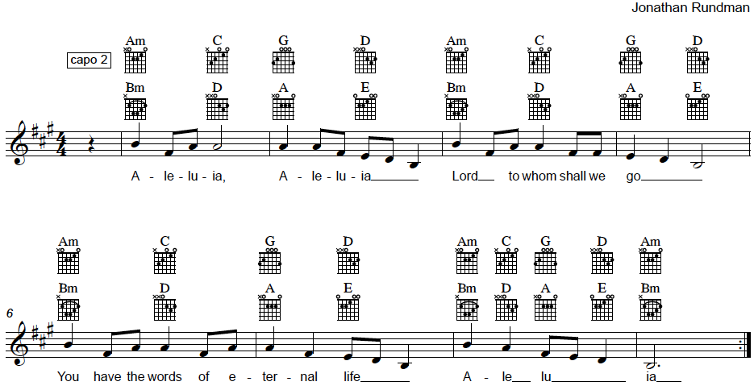

2) Glory to you, Glory to you, Glory to you O Lord (Repeat)

- Praise to you, Praise to you, Praise to you O Christ (Repeat)

- Alleluia, Alleluia, Lord to whom shall we go? (Repeat)

SCRIPTURE OF THE DAY

Matthew 11:16-19, 25-30
16 ‘But to what will I compare this generation? It is like children sitting in the market-places and calling to one another,
¹⁷ “We played the flute for you, and you did not dance;
we wailed, and you did not mourn.”
¹⁸For John came neither eating nor drinking, and they say, “He has a demon”; ¹⁹the Son of Man came eating and drinking, and they say, “Look, a glutton and a drunkard, a friend of tax-collectors and sinners!” Yet wisdom is vindicated by her deeds.’
25 At that time Jesus said, ‘I thank you, Father, Lord of heaven and earth, because you have hidden these things from the wise and the intelligent and have revealed them to infants; ²⁶yes, Father, for such was your gracious will. ²⁷All things have been handed over to me by my Father; and no one knows the Son except the Father, and no one knows the Father except the Son and anyone to whom the Son chooses to reveal him.
28 ‘Come to me, all you that are weary and are carrying heavy burdens, and I will give you rest. ²⁹Take my yoke upon you, and learn from me; for I am gentle and humble in heart, and you will find rest for your souls. ³⁰For my yoke is easy, and my burden is light.

MESSAGE AND CONVERSATION
Each week during this time we will have questions for discussion. Please participate on Zoom at your level of comfort. If you are watching a recorded version of this service, please take a moment to listen in on the conversation and think about what you would add.

(If you are joining us on Facebook Live, at this point in the service, we will be switching to a Zoom meeting so that we may interact during the sermon and prayer time. You may find the link in the comments section of Facebook.)

Prayer is a conversation with God. It’s a time to tell God about joys, sorrows, concerns, anger, or to give God thanks for the good things in life.

The Benediction is a blessing at the end of the service. People are blessed and sent out into life beyond this time and place to share the love of Jesus.

INTERACTIVE AND COMMUNITY PRAYER TIME
We will take a few minutes for silent prayer. You are welcome to pray where you are, but you may also want to step outside and catch a breath of fresh air. During this time, you may share a written prayer request on the Zoom chat. We will also ask for spoken prayer requests which we will include in our spoken community prayers. At the end of each statement of prayer, the leader will say:

Leader: Hear us O God. People: Your mercy is great.

ANNOUNCEMENTS

BENEDICTION
Pastor: May the Lord bless us and keep us. May the Lord’s face shine on us and be gracious to us. May the Lord look upon us with favor and + give us peace.
People: Amen.

SENDING HYMN – ELW 625 “Come, We That Love the Lord”

- Come, we that love the Lord, and let our joys be known; join in a song with sweet accord, join in a song with sweet accord and thus surround the throne. Refrain.

Refrain: We’re marching to Zion, beautiful, beautiful Zion: we’re marching upward to Zion, the beautiful city of God.

- Let those refuse to sing who never knew our God; but children of the heav’nly King, but children of the heav’nly King may tell their joys abroad, may tell their joys abroad. Refrain.

- The hill of Zion yields a thousand sacred sweets before we reach the heav’nly fields, before we reach the heav’nly fields, or walk the golden streets, or walk the golden streets. Refrain.

- Then let our songs abound, and ev’ry tear be dry; we’re marching through Immanuel’s ground, we’re marching through Immanuel’s ground, to fairer worlds on high, to fairer worlds on high. Refrain.

DISMISSAL
Pastor: Go in peace, Christ is with you. People: Thanks be to God.

